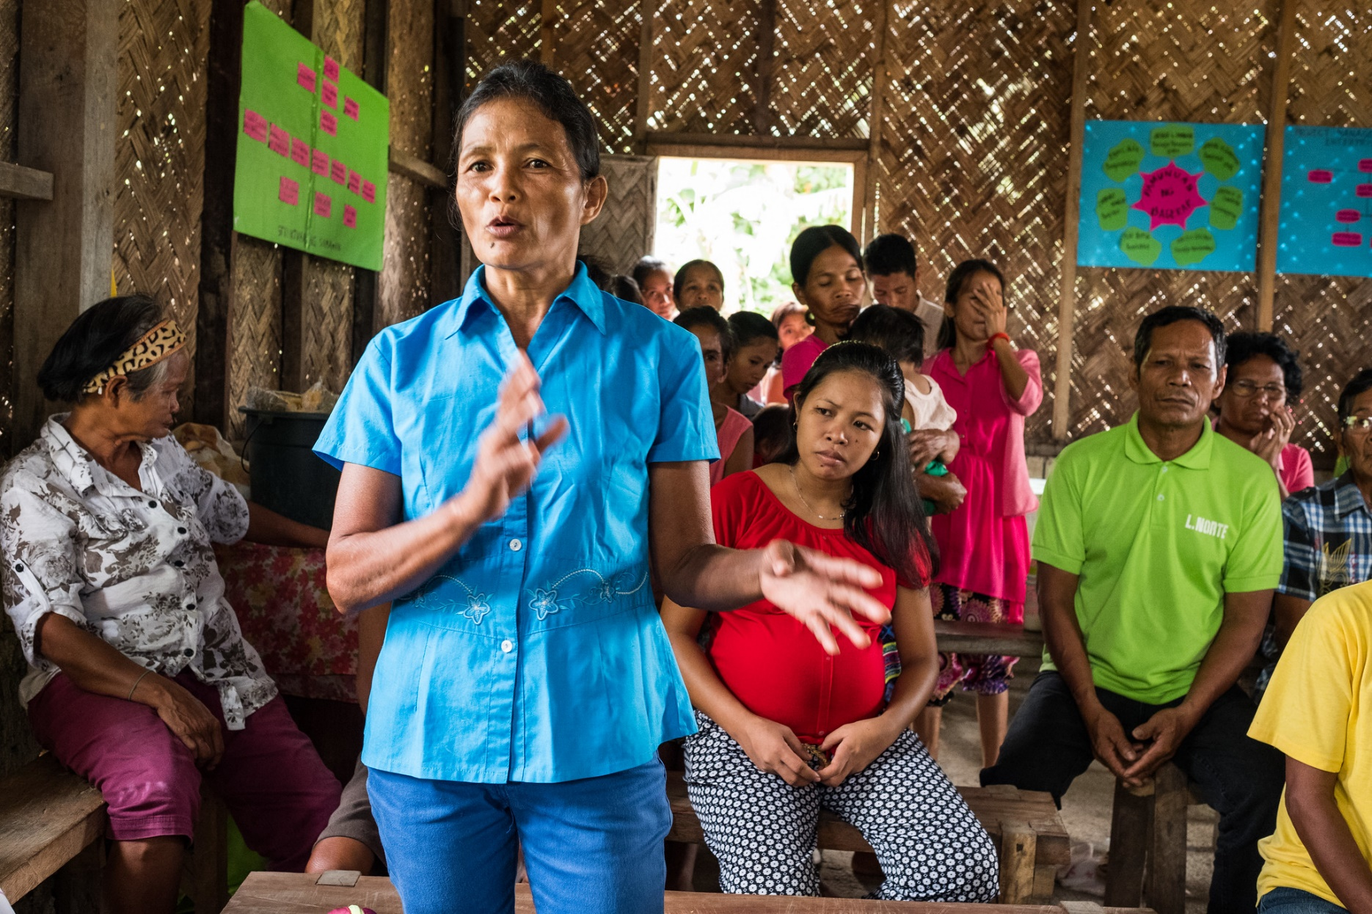

Integrated Natural Resource Management (INRM)

HEARTH Monitoring and Evaluation Toolkit:
Governance
APRIL 2022

Integrated Natural Resource Management (INRM)
Sound management of natural resources is central to long-term development and resilience. Faced with an urgent need to reduce environmental degradation while improving human well-being, solutions that effectively integrate investments in natural resource management with economic and social development are increasingly urgent. INRM promotes integrated programming across environment and non-environment sectors and across the Program Cycle. INRM supports USAID to amplify program impacts, strengthen gender equality and social inclusion, and identify best practices for integration.
For more information:
https://land-links.org/project/integrated-natural-resource-management-inrm-activity/
Date of Publication: | April 2022
Authors: | Samantha Cheng, Mike Duthie, Daniel Evans, Aaron Ferguson, Andres Gomez, Scott Miller, Christina Seybolt, and Meredith Wiggins
Front Cover photo: | Nora Abrina, President of SAKOAS Peoples Organization, Palawan, Philippines. Photograph by Jason Houston for USAID.

This document was produced for review by the United States Agency for International Development under the Strengthening Tenure and Resource Rights II (STARR II) IDIQ contract number 7200AA20F00010.
The authors’ views expressed in this publication do not necessarily reflect the views of the United States Agency for International Development or the United States Government.
Contents
Acronyms iv
Overview 1
How To Use This Toolkit 1
Outcomes and Indicators for Governance 2
Governance 3
Pathways To Change 3
Recommended Outcomes and Indicators 3
Performance Indicator Reference Sheets 5

Acronyms
DHS  HEARTH | Demographic and Health Surveys  Health, Ecosystems, and Agriculture for Resilient Thriving Societies
IIED | International Institute of Environment and Development
INRM | Integrated Natural Resource Management
IP  MERL  STARR II | Implementing Partner  Monitoring, Evaluation, Research, and Learning  Strengthening Tenure and Resource Rights II
USAID | United States Agency for International Development
USD | United States Dollar

Overview
Together, Health, Ecosystems, and Agriculture for Resilient Thriving Societies (HEARTH) and INRM have created the HEARTH Monitoring and Evaluation Toolkit, a suite of indicators and guidance that will help United States Agency for International Development (USAID) Missions and implementing partners (IPs) monitor progress and aggregate common metrics to build the evidence base around the effectiveness of integrated strategic approaches. This document is an individual module from the toolkit, presented separately to facilitate use by individual HEARTH activities. Before using this module, we recommend first accessing the full toolkit and reviewing the list of sectors covered by each module, and determining which are most relevant for your activity:
Access Full Toolkit on Biodiversity Links Here.

How To Use This Toolkit
This toolkit presents a menu of options for outcomes and recommended indicators across the HEARTH activities. Before using this toolkit, activities should have developed a robust theory of change – through first drafting their situation model and results chains during the co-design workshops, many of which have been completed already, and then validating and refining those results chains during start-up workshops.
Based on the activity theory of change, HEARTHs should develop their Activity Monitoring, Evaluation, Research, and Learning (MERL) Plan, which should draw directly from the toolkit. It is not expected that all outcomes or indicators will be relevant for all activities, but that activities should select those in line with their results chains and activity theory of change. Additionally, there might be activity-specific outcomes not included in this toolkit because they were not generally applicable across the HEARTH portfolio, and Missions and IPs should therefore include additional indicators in their MERL plans, as relevant.
When developing activity MERL plans, the indicators in this toolkit are intended to be used both to standardize reporting for monitoring data, as well as a basis for evaluation data collection. While monitoring trends in these indicators over time may be important for some activities, USAID anticipates that Missions and IPs will also identify important questions about the causal impact of their activities during the start-up activities, best answered using evaluation approaches. Which indicators will be part of monitoring systems, and which will be used to answer evaluation questions, will affect how the toolkit is operationalized. In addition, it is expected that MERL plans will likely include qualitative data sources, important to further explaining monitoring and evaluation results and exploring learning questions in more depth, in addition to the quantitative data collected using the approaches from the toolkit.

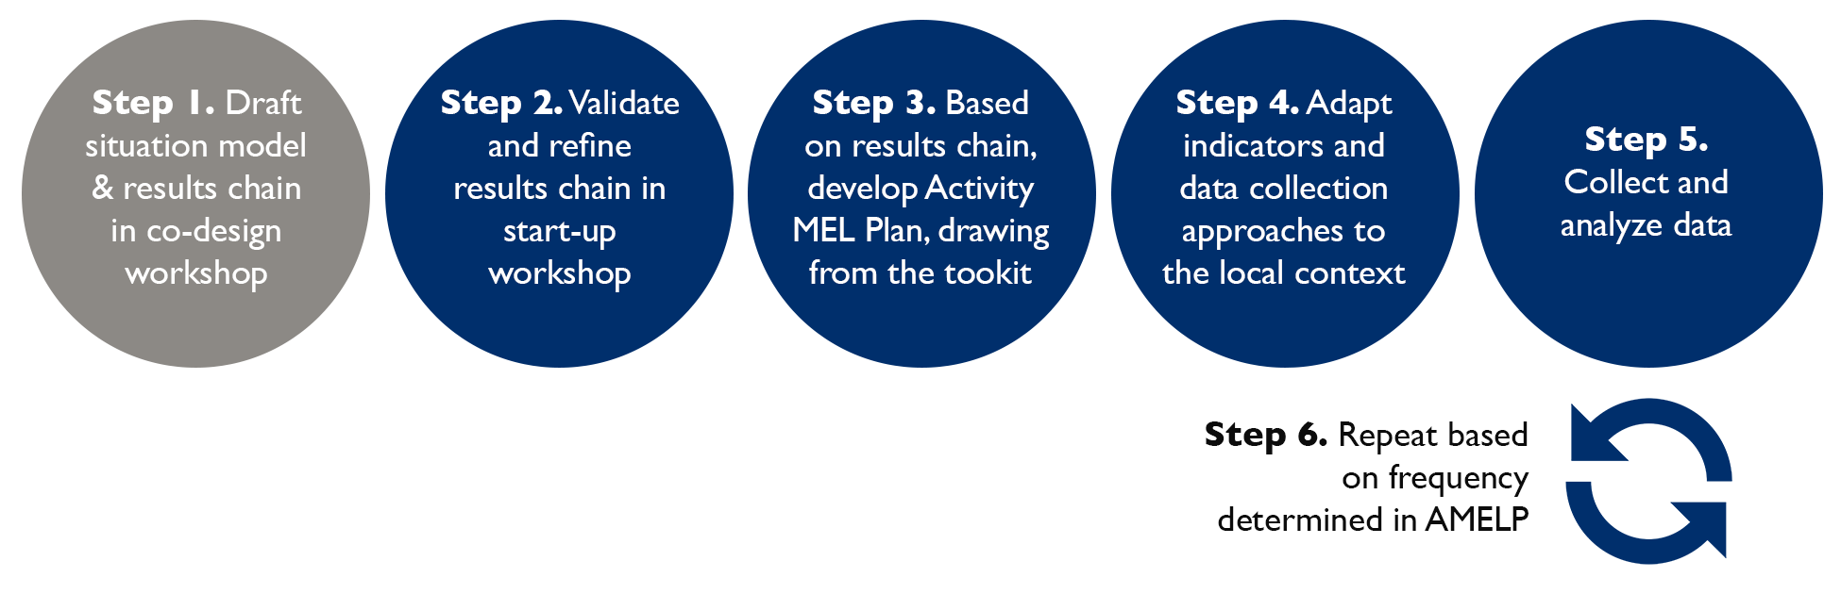

Outcomes and Indicators for Governance
Table 1: Overview of Outcomes and Recommended Indicators for the Governance Sector.
Outcomes | HEARTH Portfolio Indicators
- Increased community participation in resource governance  - Increased rights and/or security  - Strengthened resolution mechanisms  - Improved monitoring and enforcement | - Average score across Site-Level Assessment of Governance and Equity (SAGE) outcome areas

Governance

Pathways To Change
Many HEARTH activities include strategic approaches related to improved governance including community participation, rights/security, resolution mechanisms, and monitoring/enforcement. These improvements in governance and natural resource management are important intermediary links for other outcomes, particularly biophysical. To better measure the role of various stakeholder groups in governance, it is recommended that this set of outcomes be measured through a community-level assessment tool as opposed to the core HEARTH household survey questionnaire.

Recommended Outcomes and Indicators
Outcome | Description | Recommended Indicator & Duration
Increased community participation in resource governance  Increase in rights and/or security  Strengthened resolution mechanisms  Monitoring and enforcement | SAGE is a participatory assessment methodology, developed to measure a variety of governance outcomes including the following:  - Participation in decision-making  - Recognition of rights  - Transparency and accountability  - Access to justice including effective dispute resolution  - Fair and effective law enforcement  - Benefits sharing  - Achievement of conservation and other related objectives  - Effective intersectoral coordination and collaboration  This participatory approach is in line with HEARTH’s commitment to engaging with beneficiaries throughout the Program Cycle.  If of interest, HEARTH activities may add governance related questions to the household-level survey as well. This would be in addition to existing questions on participation in farmer, water, and forest user groups in the Agriculture and Land module. | Indicator: Average score across SAGE outcome areas  Source: International Institute of Environment and Development (IIED)  Duration: 4-6 weeks in total including 1-2 days of facilitated data collection for each site-level assessment

Performance Indicator Reference Sheets
INDICATOR TITLE: Average score across SAGE outcome areas
DEFINITION:
SAGE is a stakeholder-led assessment conducted at the community level to enable site-level actors to improve the governance and equity of their conservation and related work to improve both social and conservation outcomes. SAGE also generates information for actors at higher levels for management oversight, improving governance of area-based conservation measures. This approach was developed by the IIED and has been pilot tested in nine countries. The SAGE methodology measures program outcomes both quantitatively and qualitatively, provides a shared learning experience across stakeholders, and generates learning and ideas for adaptive management.
SAGE tracks outcomes based on 10 principles of governance and equity, which overlap with relevant outcomes areas for HEARTH. As a practical matter, SAGE recommends limiting the assessment to eight outcomes. For HEARTH, these should include:
- Full and effective participation of all relevant actors in decision-making
- Recognition of rights of community members
- Transparency, information sharing, and accountability
- Access to justice including effective dispute resolution processes
- Fair and effective law enforcement
- Benefits equitably shared among relevant actors
- Achievement of conservation and other related objectives
- Effective intersectoral coordination and collaboration between actors, sectors, and levels
The last of these—effective intersectoral collaboration—is especially important for HEARTH, given the co-creation of its activities by the private sector, communities, government, and civil society partners. The participatory assessment methodology of SAGE includes all of these stakeholders, including specific mechanisms to ensure the full participation of women and marginalized groups.
The SAGE manual (April 2021 PDF) provides additional details for reporting and survey questions.
DATA COLLECTION:
Individuals from each stakeholder group are convened and led in a facilitated assessment over the course of 1-2 days. Each stakeholder group scores each outcome area on a scale of 0-3 based on questions that SAGE has prepared (questions can be tailored as appropriate for each HEARTH site). Group members are asked to provide evidence for their opinions and to offer any specific ideas for action. These responses are recorded.
This is followed the next day by a synthesis workshop that brings together the stakeholder groups and shares their respective governance and equity assessment results. This discussion explains any differences of opinion, narrowing those differences where possible based on additional information exchanged by the participants. A summary table and graphic show the average score for each outcome, taking account of any changes in responses that may have been made as a result of the discussion. In addition to the scores, the summary table for each outcome includes identification of key issues, questions reflecting large differences in groups’ scores, and ideas for action to improve divergent responses.
SAGE assessments are intended to be done after two years of operation of program management and governance systems, with options for using qualitative outcome harvesting measurement techniques in between full SAGE assessments. However, it is also recommended to conduct assessments at project start-up to both provide a comparison for change over time, as well as potentially inform programming needs.
ADAPTATION:
While eight outcomes are recommended, it is possible that HEARTH activities may add or remove outcomes as relevant for their theories of change. For example, law enforcement might be more relevant for activities that have strategic approaches focusing on improvements to monitoring and enforcement systems, but not others.
In addition, the questions that are asked to each stakeholder group to score each outcome area should also be tailored as appropriate for each HEARTH activity. For example, one of the questions for the respect for rights outcome is “What proportion of adults in the community are aware of their right to [insert a relevant right]?” which would need to be adapted to the local context.
COST CONSIDERATIONS:
For each site-level assessment, one experienced facilitator and two to four less experienced facilitators are required, along with a few local note takers. Including the preparatory stakeholder analysis and site profile, the assessment takes 4-6 weeks. In areas with multiple sites, the assessment may be conducted in a central location or may be based on representative sampling. IIED estimates that the range of costs for an assessment is United Stated Dollar (USD) 2,000-10,000, with recent experiences in the range of approximately USD 6,000-7,000.
While there are several IIED-certified SAGE facilitators and more are currently being trained across multiple countries, there may be a need for training additional facilitators. This would only take a day or two and add some modest cost, but the key consideration is to ensure quality control for the facilitation process.
UNIT:  Score ranging from 0 to 3 | DISAGGREGATE BY:  Each outcome area included in the assessment
TYPE:  Outcome | DIRECTION OF CHANGE:  Higher is better
REPORTING NOTES
See additional details in the SAGE manual (April 2021 PDF) regarding reporting

“State-Level Governance, U.S.” The SAGE Encyclopedia of Higher Education, 2020. https://doi.org/10.4135/9781529714395.n522. https://www.iied.org/site-level-assessment-governance-equity-sage.
ibid

